Dynamdb lab

Create 4 tables using PHP scripts and use EC2 instance to interact with Dynamodb . A role is assigned to EC2 instance to interact with Dynamodb

1. Create a role called Dynamodbrole with DynamodbFullAccess

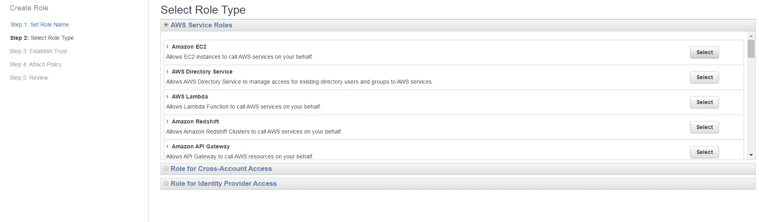

1. Choose the EC2 instance



1. Filter the DynamodbFullAccess role and select it

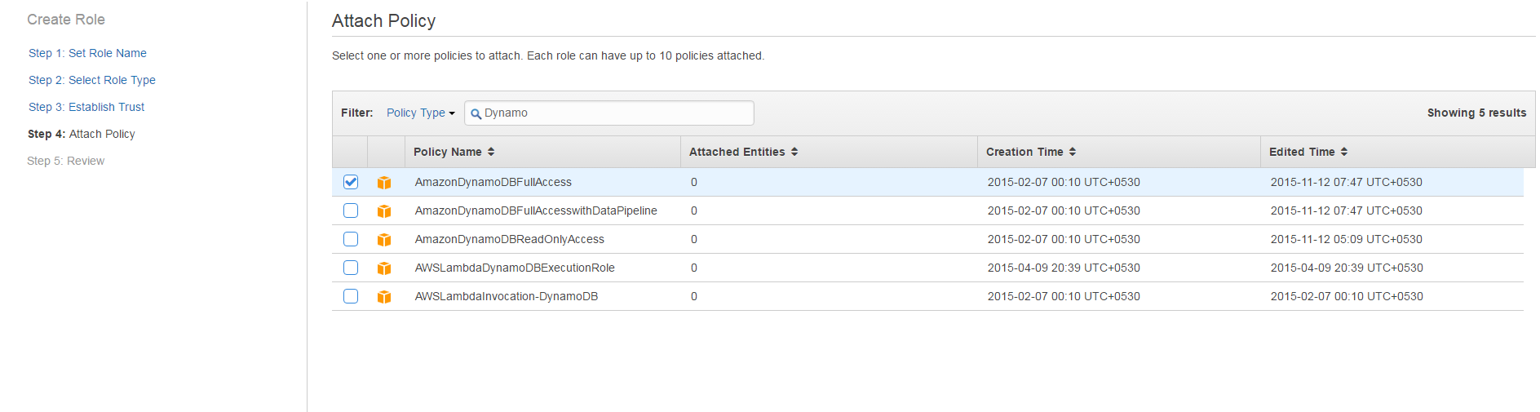

1. Click create role
2. Navigate to EC2 , launch a new instance
3. Follow the same steps to launch an instance
4. Choose IAM role as DynamoDB and copy and paste the bootstrap script in Advanced Details workspace.

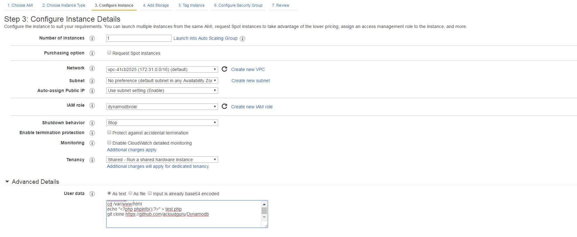

1. Provide an instance tag as Dynamodbinst

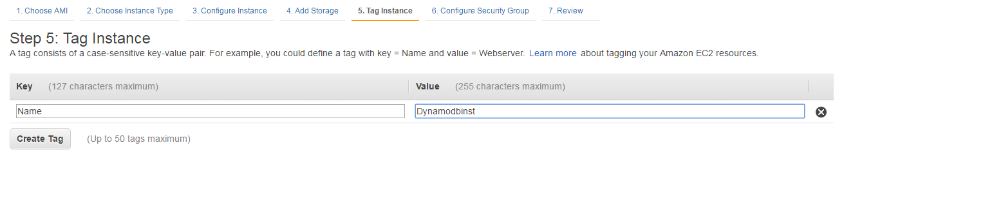

1. Choose the existing security group

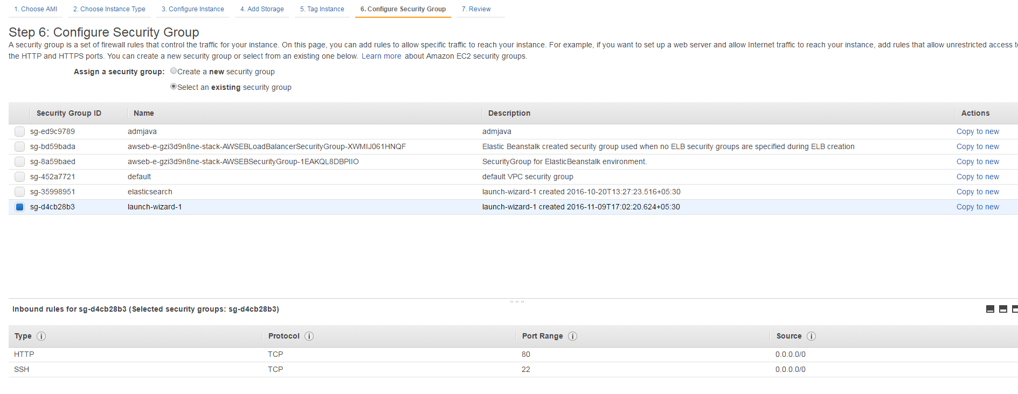

1. Choose the existing key pair and launch the instance.

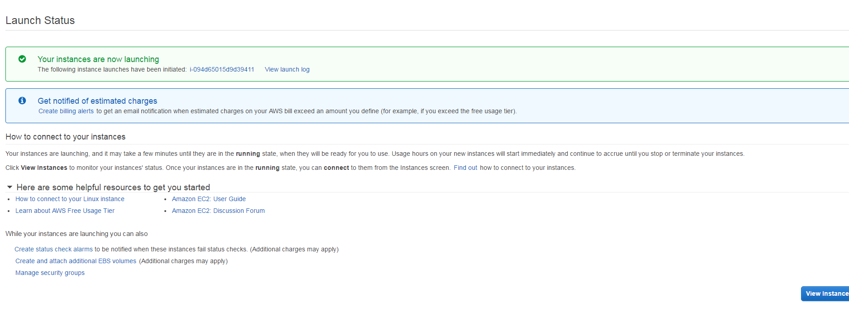

1. Copy and paste the Public IP in putty and connect to EC2 instance

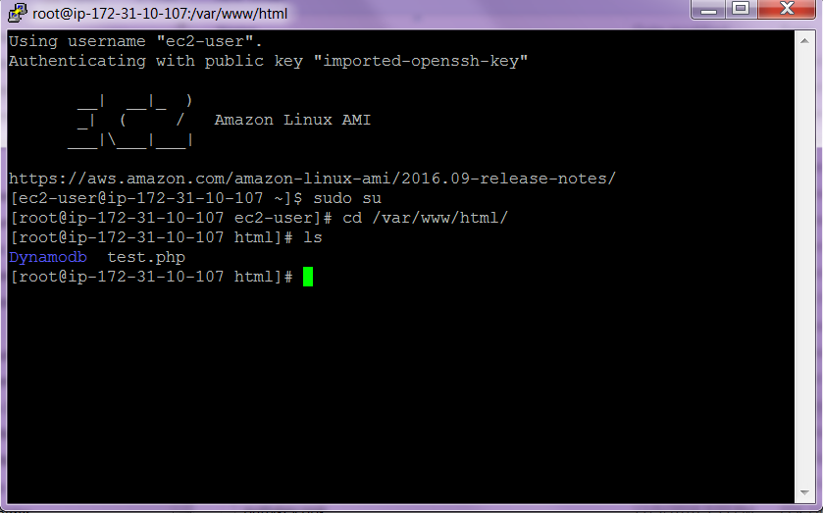

1. Type aws php sdk and download the php sdk as done earlier

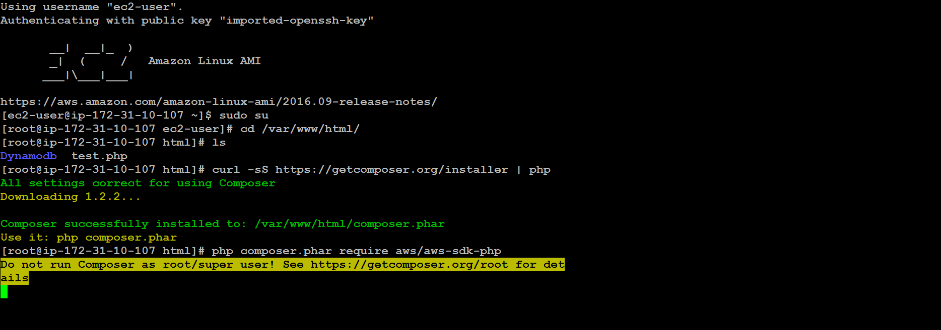

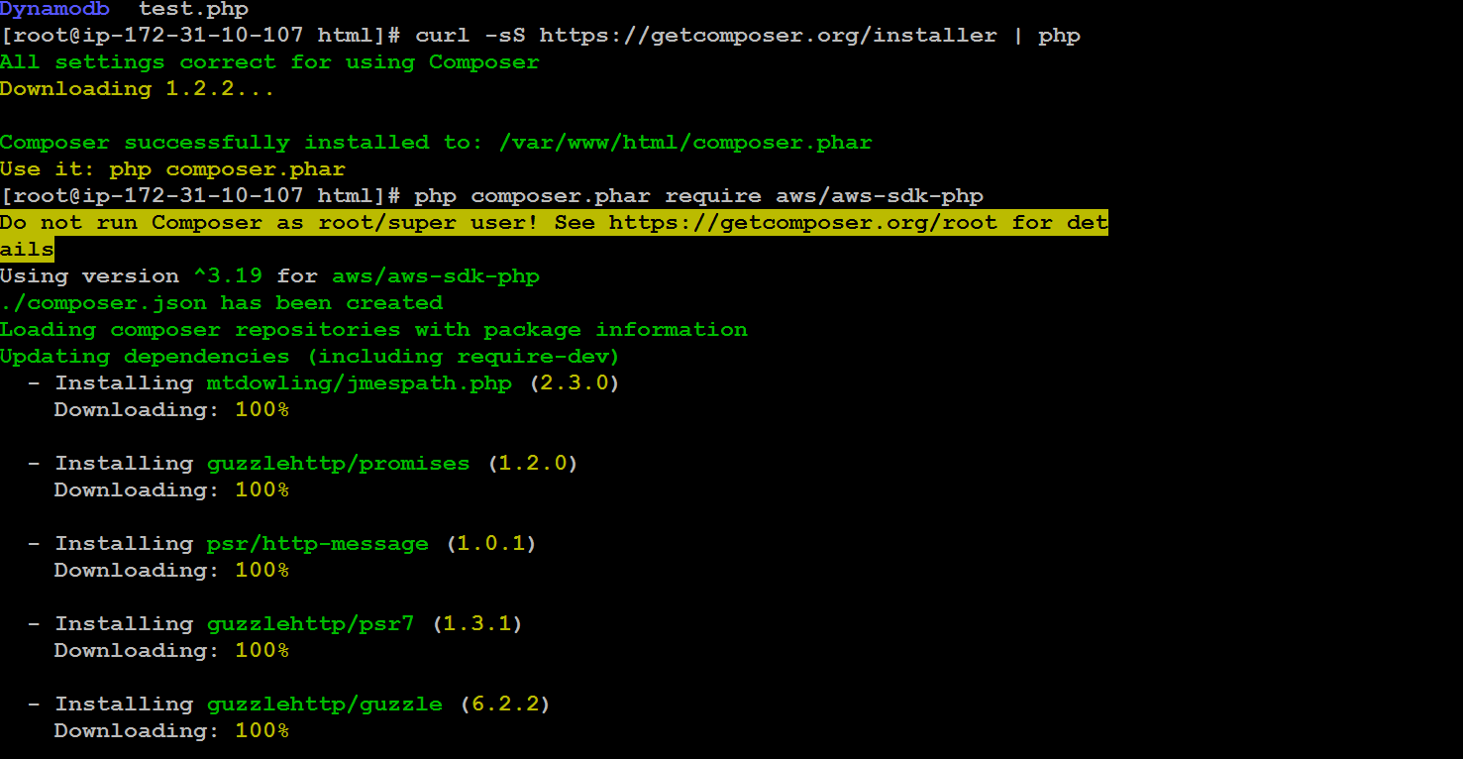

cd to Dynamodb directory and list the files

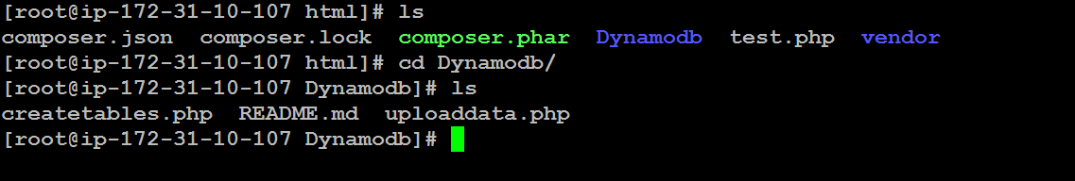

Change the region according to the region that your are working .

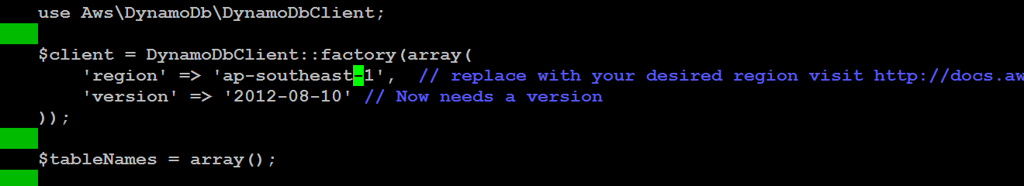

Save the changes and exit

Open a browser and type the url <http://52.221.246.79/Dynamodb/createtables.php>

It displays the page with table creation



In Aws console –click Services 🡪dyna modb🡪 See the tables created .

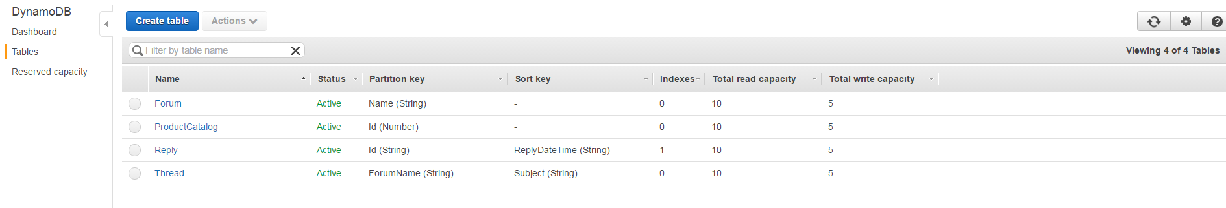

In command line nano uplaoddata.php and change the region and save the changes

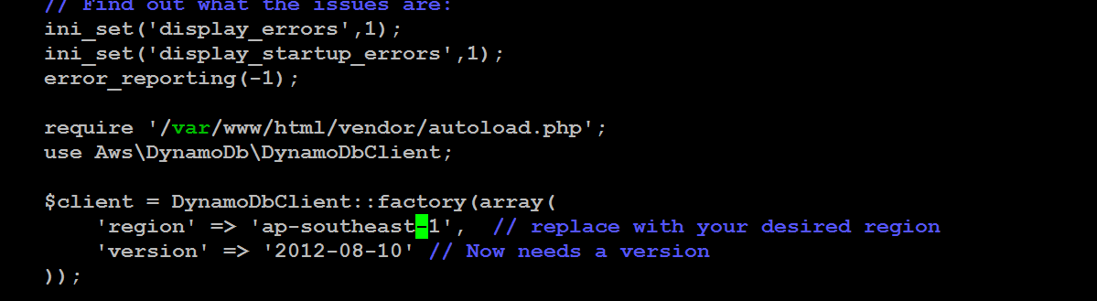

To upload data, type <http://52.221.246.79/Dynamodb/uploaddata.php>



Navigate to Dynamodb 🡪 click on the table 🡪Items and see the records

